**About the Program**

**Course Road Map**

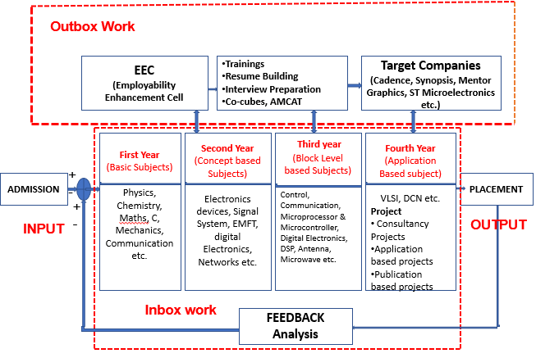

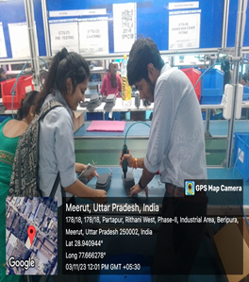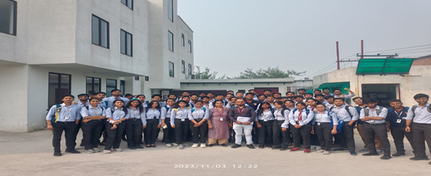**Industrial Visits**

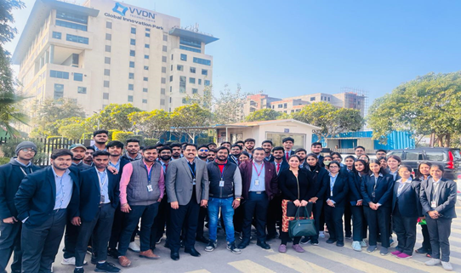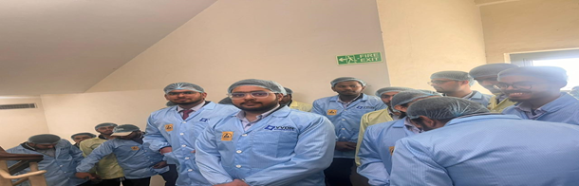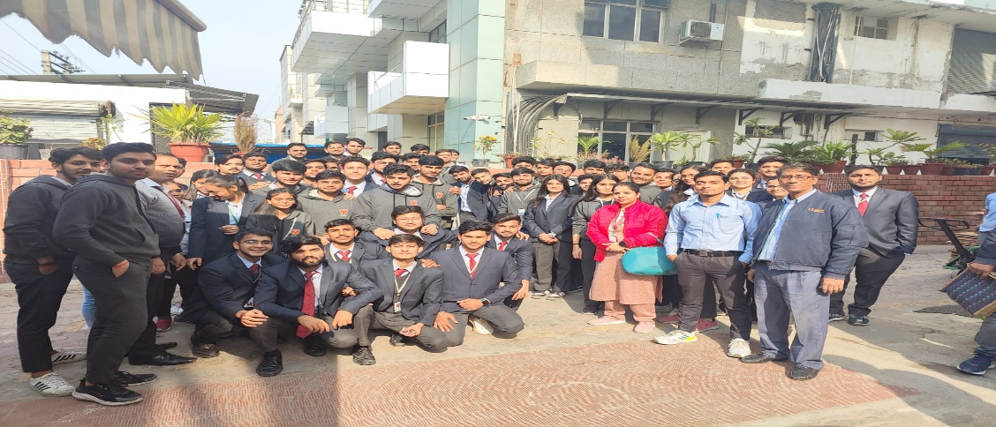

|  |  |  |  |  |  |
| --- | --- | --- | --- | --- | --- |
|  | | | | | |
| **S.No** | **Session** | **Date of Visit** | **Name of Industry Visited** | **Students Participated** |
| 1 | 2023-24 | 3rd November, 2023 | Akshat Autoline Private Ltd, Meerut | 60 |
| 2 | 14th December,2023 | Deki Electronics, Noida | 56 |
| 3 | 2nd February , 2024 | VVDN Technologies Pvt Ltd, Gurugram | 50 |
| 4 | 2022-23 | 28th September,2022 | Deki Electronics, Noida | 52 |
| 5 | 30th September,2022 | Akshat Autoline Private Ltd , Meerut | 56 |
| 6 | 21st March ,2023 | Bisleri International Pvt Ltd | 55 |
| 7 | 22nd March,2023 | CFEES, cluster of DRDO | 55 |

**Training Roadmap**

|  |  |  |  |  |  |
| --- | --- | --- | --- | --- | --- |
| Year | S. No. | Name of the Training | Area of Training | | |
| Third Year | 1 | Design and Verification using Verilog & Xilinx Tools (Level 1 & 2) | Microelectronics & VLSI | | |
| 2 | Schematic and Layout Design of VLSI Circuits | Microelectronics & VLSI | | |
| 3 | Embedded Systems and IOT (Level 1 & 2) | Embedded Systems | | |
| 4 | Automation Advanced Course by National Instruments (Image Processing) | Automation | | |
| 5 | RF & Microwave Devices | Communication | | |
| Year | S. No. | Name of the Training | | Area of Training |
| Second Year | 1 | Electronics Circuit Design | | Microelectronics & VLSI |
| 2 | Microcontroller & Embedded Systems | | Embedded Systems |
| 3 | Advanced Communication using MATLAB | | Communication |
| 4 | Industrial Automation | | Automation |
| 5 | Electric Vehicle Technology | | Electric Vehicle |

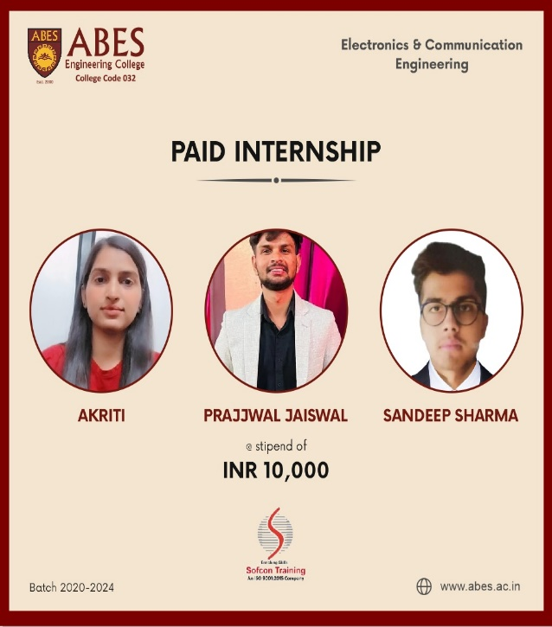**Top Internship Offers**

**Top Placement Companies**

|  |  |  |
| --- | --- | --- |
| S. No. | Company | Package |
| 1 | ZenTrades India Pvt. Ltd | ₹ 10,20,000 |
| 2 | Hiremi | ₹ 10,00,000 |
| 3 | Centilytics | ₹ 8,10,000 |
| 4 | Datatrained Education Pvt. Ltd. | ₹ 7,85,000 |
| 5 | MATQCODE Internet Labs Pvt. Ltd. | ₹ 7,20,000 |
| 6 | Weskill Edutech Private Limited | ₹ 7,00,000 |
| 7 | PlanetSpark | ₹ 6,50,000 |
| 8 | Hike Education | ₹ 6,42,000 |
| 9 | Hexaware Technologies Ltd. | ₹ 6,00,000 |
| 10 | SKLR EDTEC PVT. LTD. | ₹ 6,00,000 |
| 11 | SMS group | ₹ 5,50,000 |
| 12 | Lutron GL Sales & Services Pvt. Ltd.-1 | ₹ 5,24,688 |

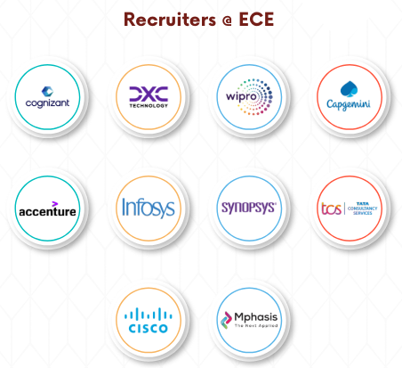

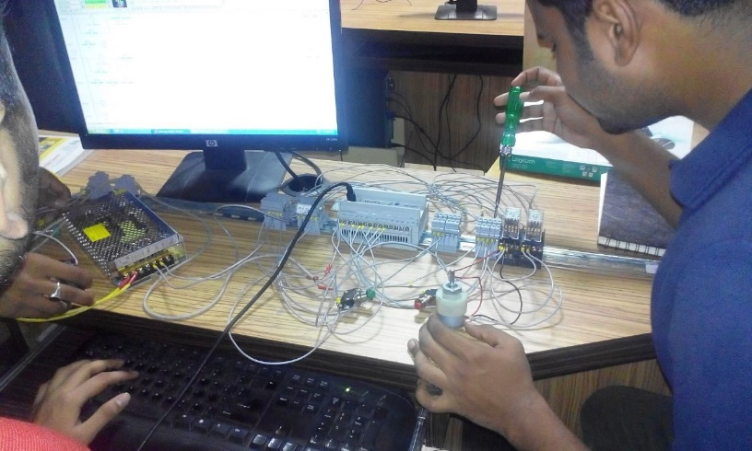**Facilities and Labs**

**Events & News**

|  |  |
| --- | --- |
| **S.No.** | **Event Name** |
| **1** | A session on "**Role and support of Incubator/Accelerator for faculties and students"** |
| **2** | **Webinar-1** of **Webinar-series** on the topic**“A pathway for preparing budding Engineers to unlock corporate world options”**. |
| **3** | **1st International Conference on Sustainable Emerging Innovations in Engineering and Technology (ICSEIST-23), technically sponsored by IEEE, funded by MeitY & SERB**, |
| **4** | Webinar 2 of Webinar Series **“A pathway for preparing budding Engineers to unlock corporate world options”** |
| **5** | Industrial visit to**"Akshat Autoline Pvt. Ltd", Meerut** |
| **6** | Inaugural Ceremony of **WIE(Women In Engineering)**in collaboration with ABESEC **OPTICA and REQUIZA – THE TECHNICAL SOCIETY OF ECE DEPARTMENT, Expert Lecture and BRAIN-O-RACE 2.0,”** |
| **7** | Industrial visit to **Deki Electronics Private Ltd. Sector 58, Noida**for the students of **ECE-II Year** |
| **8** | **NATIONAL ENGINEERS’ WEEK CELEBRATION** |

**NATIONAL ENGINEERS’ WEEK CELEBRATION**

**1. International Student Chapters “ABESEC OPTICA” (formerly ABESECOSA) and IEEE MTTS have organized National Engineers’ week from February 20, 2023 to February 24, 2023.**

Several events were conducted and lectures from renowned professionals from industry and academia were organized for the benefit of students.

2. **International Student Chapter “ABESEC OPTICA” (formerly ABESECOSA) has orgnized National Engineers’ week from February 19, 2024 to February 23, 2024.**

